Trends of alternative informality measures in LAC

Todo

1. Organize the methodological details contained in the [CN-doc](https://worldbankgroup.sharepoint.com/teams/InformalityinLCR-WBGroup/Shared%20Documents/Section%200%20-%20General%20introduction/scratch/Documents/Figures%20for%20concept%20note.docx) as an appendix of this document – generate a new document ( Methodology Latest Trends.docx)
2. Include Regional figures.

***Figure 1a. Evolution of alternative informality related measures***

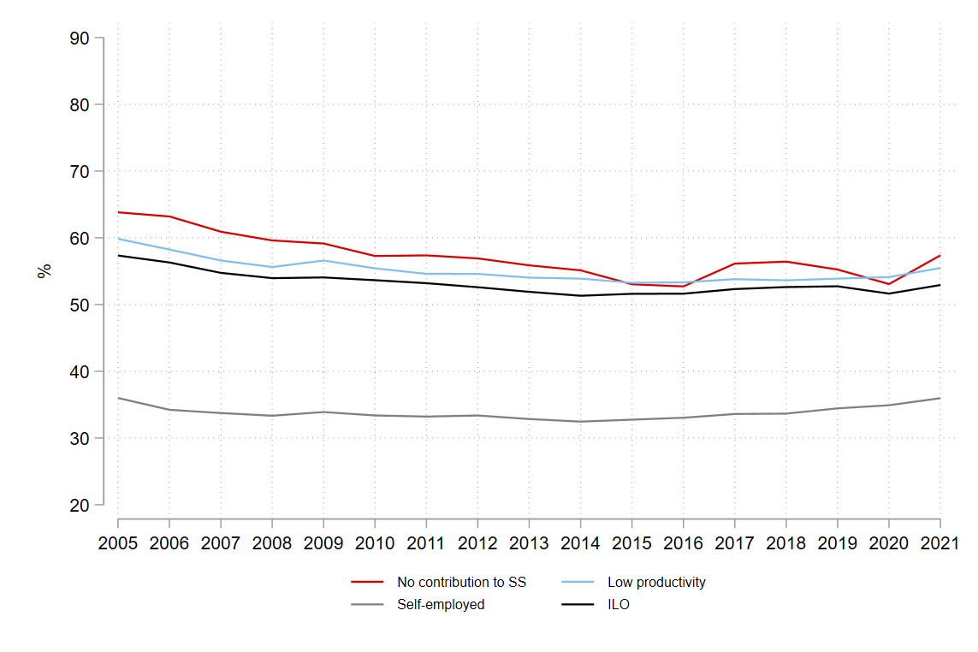

***Figure 1b. Evolution of alternative informality related measures***

Source: SEDLAC and ILO.

*Note SEDLAC: Both figures show unweighted means of country level indicators. The countries included in the sample are Argentina, Bolivia, Brazil, Colombia, Costa Rica, Ecuador, Honduras, Mexico, Panama, Peru, Paraguay, El Salvador and Uruguay. Some countries don’t have information for the entire period: Bolivia and Brazil have missing values in 2010; Colombia have missing values in 2006 and 2007; Honduras have missing values in 2020-2021; Mexico have missing values 2005, 2007, 2009, 2011, 2013, 2015, 2017, 2019, 2020, 2021; Panama and El Salvador have missing values 2020; and Uruguay have missing values in 2021. *In that cases we interpolate the sample using the closest last year value.*

*Note ILO: The serie is a modeled estimated informal employment rate by ILO.

1. Include cross country figures

***Graph 2.1. Snapshot of LAC’s household contribution status -last available year***A graph of different colored bars

Description automatically generated with medium confidence

*Note: Some countries don’t have information for 2021, in that cases we use the last available year, Chile 2017, Guatemala 2014; Honduras 2019; Mexico 2018 and Uruguay 2019.

***Graph 2.2. Snapshot of LAC’s household employment condition for 2005-2021***

*Note: Some countries don’t have information for the 2005 or 2020, in those cases we are using the closest year, for Bolivia 2002; Chile 2006 and 2017; Colombia 2008; Guatemala 2004 and 2014; Mexico 2006 and 2018; Honduras 2019 and Uruguay 2019.

*About the definitions: *All contribute: corresponds to the percentage of households where all workers contribute to SS. Some contribute: corresponds to the percentage of households where some workers contribute to SS but not all. DNC – has partner: corresponds to the percentage of households where any worker contributes to SS, but the head of household have a partner. DNC – no partner: corresponds to the percentage of households where any worker contributes to SS, but the head of household do not have a partner.*

1. Create a document with cross country graphs

***Graph 3.1. Salaried who don’t contribute to SS***

*Note: Some countries don’t have information for the chosen years, in that cases we are using the closest year, for Bolivia 2002; Chile 2010; Colombia 2008; Guatemala 2004 and 2014; Mexico 2006 and 2018; Honduras 2019 and Uruguay 2019.

***Graph 3.2. Salaried who work at small firms.***

*Note: Some countries don’t have information for the chosen years, in that cases we are using the closest year, for Bolivia 2002; Chile 2010; Colombia 2008; Guatemala 2004 and 2014; Mexico 2006 and 2018; Honduras 2019 and Uruguay 2019.